Top Shopify Apps for Last-Mile Delivery
A seamless service from product search to delivery is the aim of every online retailer, so anything that improves the process is to be welcomed. But it’s the last mile that could prove the most critical in the purchasing journey.
Image Credit
According to Retail Sector, the option of having their purchase delivered within two days could make all the difference in persuading over 70% of consumers to buy goods online. So with that in mind, we’ve come up with the top Shopify apps that streamline your options.
Delivery Date Range
A clever little plug-in that gives a guide to anticipated delivery dates, the Delivery Date Range app appears on the actual product page, thereby encouraging customers to stay on the page and complete their transaction. Easily customised by the retailer, this app lets users define their own content, which can then be combined with a countdown clock. This gives a further incentive to buy.
Retailers can then work in conjunction with local or national courier services to offer the optimum delivery service. For example, for a company in Slough same day courier services might necessitate offering a dedicated tracking service in real time. The company can then ensure that it employs a Slough same day courier company that offers this facility as an added feature that it can provide for consumers.
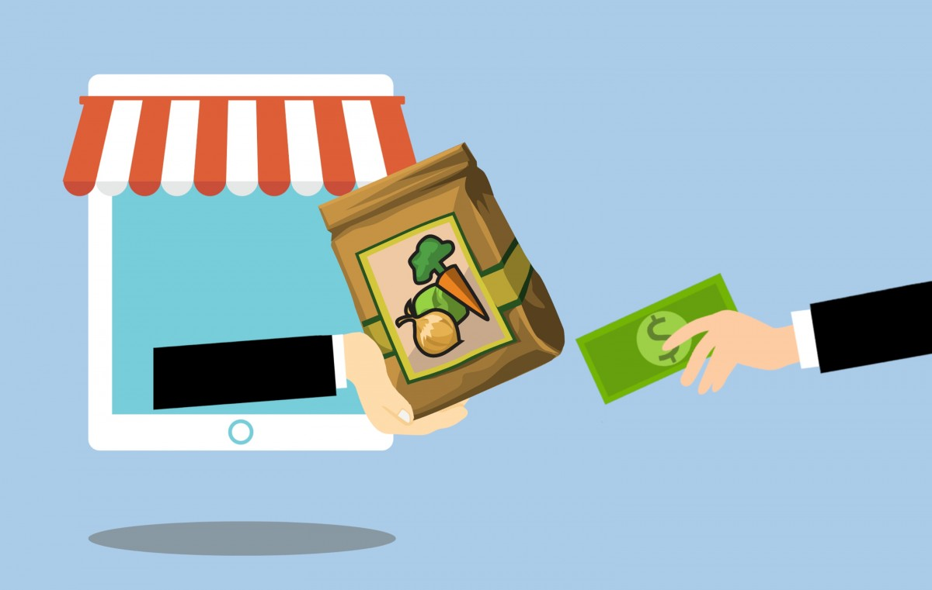
Image Credit
Gophr
With same-day delivery services becoming increasingly popular, Gophr’s ability to offer same-day delivery and tracking within the UK makes it a highly useful app. Using real-time technology, Gophr is able to quote a price for a delivery in real time at the checkout, enabling a swift and smooth transaction that inspires confidence in the purchaser. For the seller, meanwhile, optimum routes can be arranged, enabling the best pricing for customers, together with GPS tracking for constantly updated information.
UK Click & Collect
Always a popular alternative option for consumers, Click & Collect offers superb choice, cutting costs while enhancing the available delivery options. UK Click & Collect gives sellers access to more than 4000 dedicated pick-up places within the UK, letting consumers choose their most convenient location. The app was created by HubBox, and it offers sellers access to a portal that streamlines their parcel shipping process, with the added bonus that it can be adapted for use with any courier service.

